**AGGREGATE FUNCTIONS MIN AND MAX**

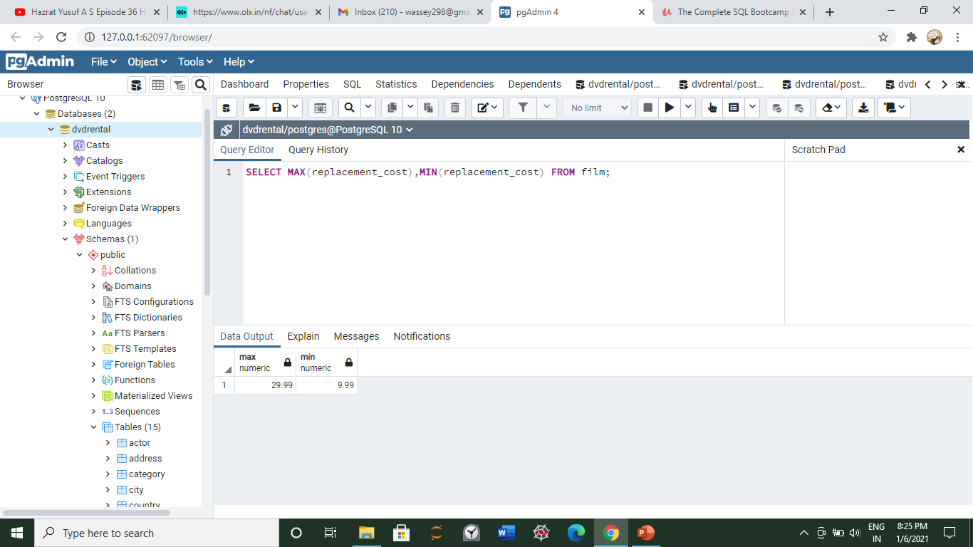

**TO KNOW HOW MANY ROWS WE HAVE**

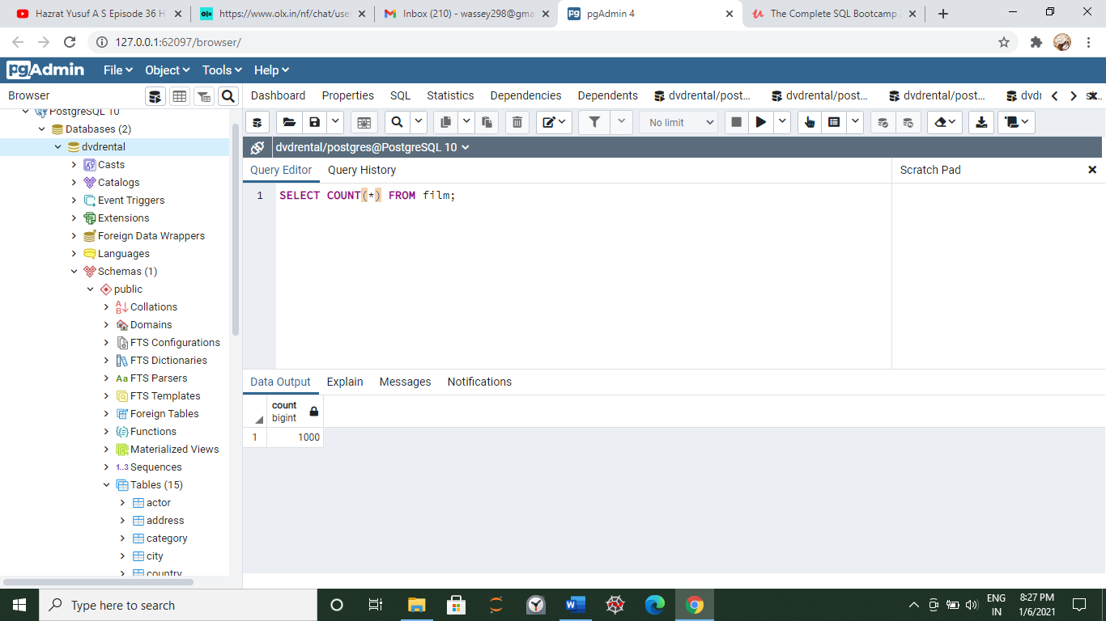

**ROUND AND AVG WITH DECIMAL VALUES**

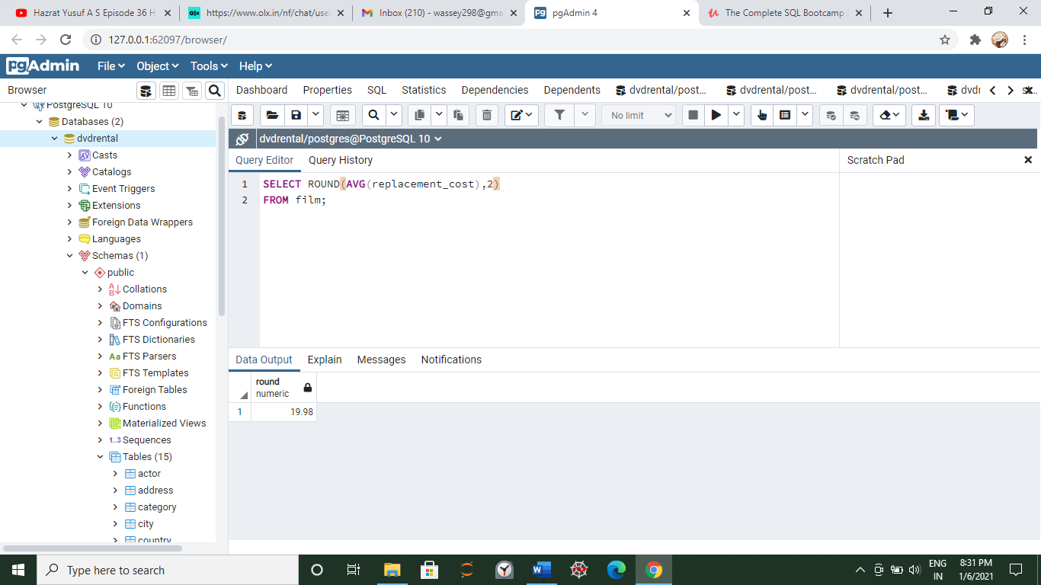

**SUM FUNCTION**

